**User-Guide Experience**

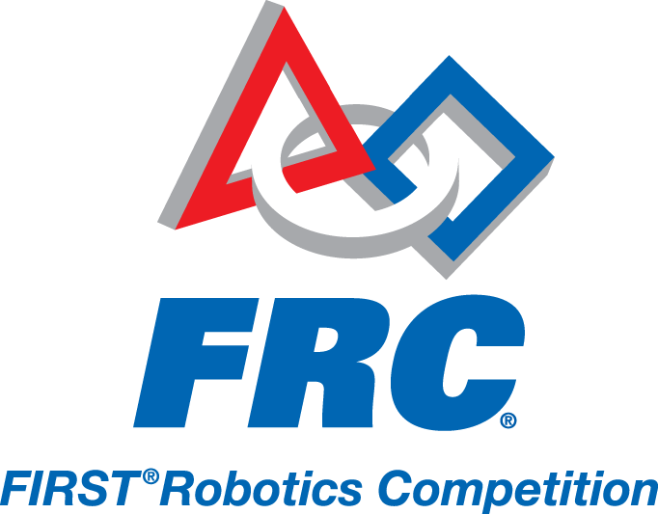

The program is designed to be intuitive and user-friendly. Most of the options and buttons are self-explanatory. Whenever, the form loads up; the user has to enter the following mandatory details: Team number, Team name and select pre-match or in-match from the radio buttons. If the user has not selected any of the radio buttons, he cannot enter any of the autonomous details. The form contains FRC logo on the top to provide a good interface.

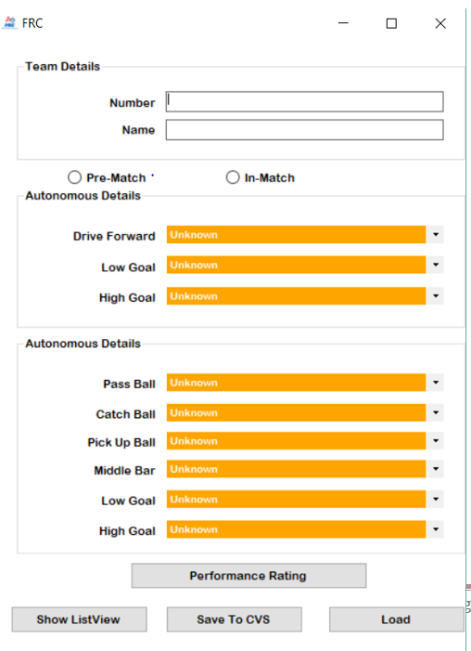

Figure 1 The form that loads up as we run the program

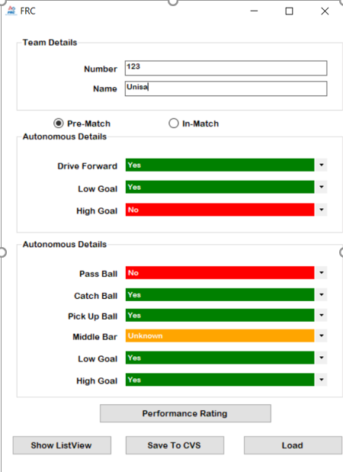

Figure 2 Form with all the details entered by the user

The user can only enter digits for Team number. Yes is shown as green, no by red and unknown by orange colour.

Save to cvs button is used to save the information as a cvs file.

Load is sued to open up a pre-existing excel file.

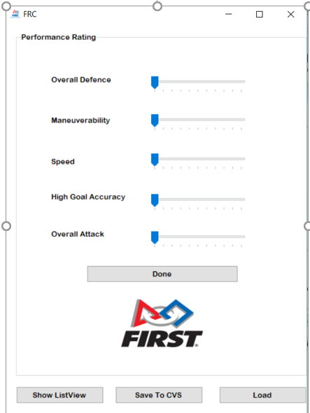

Figure 3 Performance can be rated here

The user can click on performance rating button in figure 2 and reach to this form to rate the robot's performance.

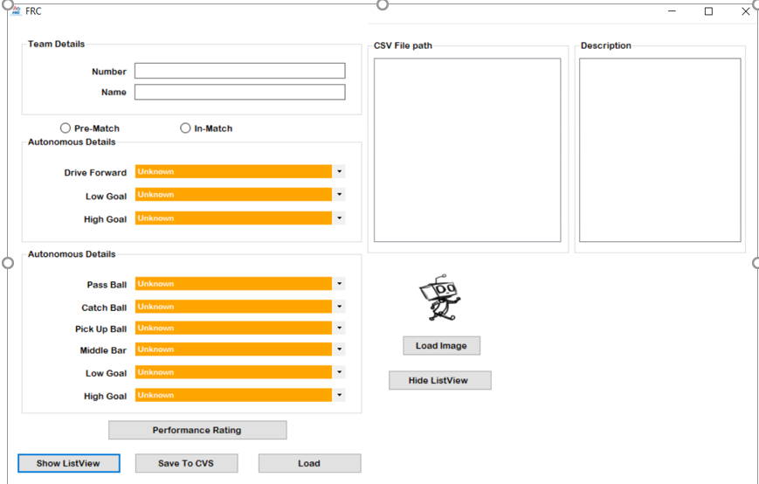

Figure 4 Show List View button will extend the form into this screen

The user can click on the Show list view to extend the form. The saved CSV file paths can be found in CSV file path window as figure 5. We can write description about the robot in description Text box and when the form is saved this description is saved in the CSV file as well as shown in Figure 7.

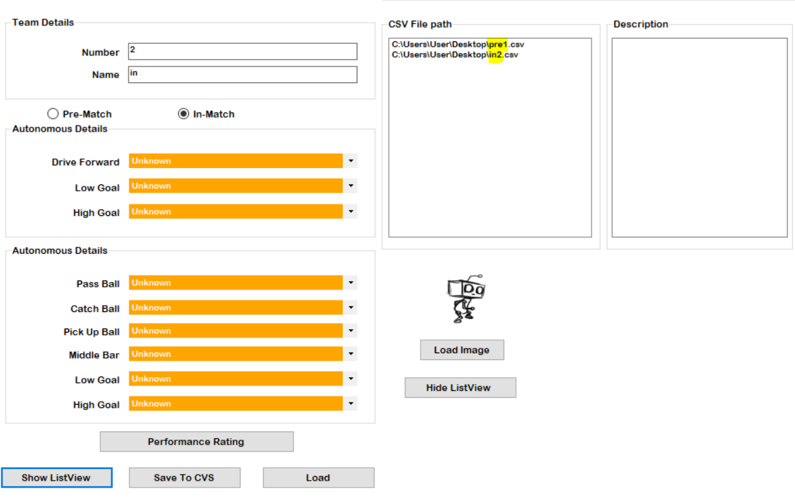

Figure 5 The file path showing the different CSV saved under pre and in-match names

The user can open CSV from these file paths.

Figure 6 the form with uploaded photo and some description written.The URL of the file path of the image will be saved in the CSV as shown in figure 7. 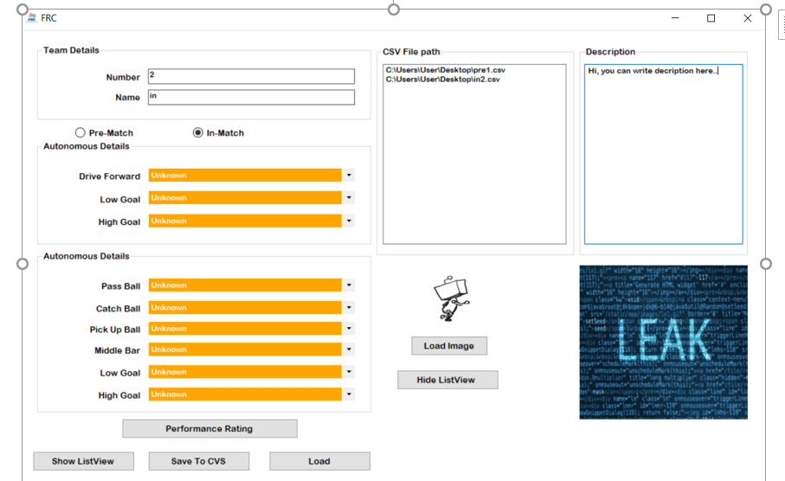

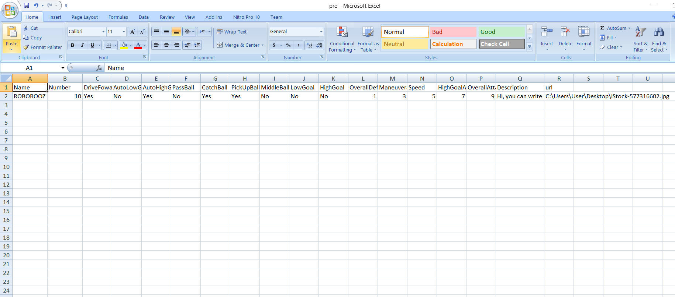

Figure 7 All the details entered in the form saved in a CSV file.